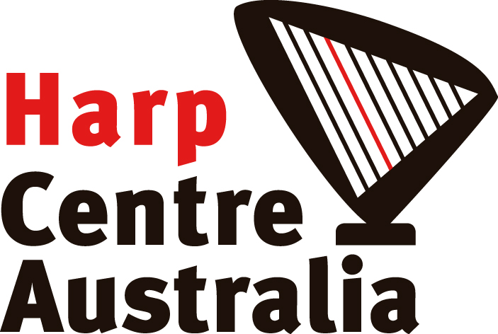
12th KIOLOA SUMMER HARP COURSES, 2017 APPLICATION FORM
January 10th - 16th / 17th - 19th 2017

Personal Information:

Name:..................................................................................................................................

Address:...........................................................................................................................................................................................................................................................................
………………………………………………………………………………………………………
Phone:.........................................................Email:...............................................................
Name of accompanying person (if applicable):......................................................................

I would like to register for (all prices include GST):
All prices also include full course fee, accommodation and at least 6 evening meals
Course Participant
☐ $1,520 ☐ HCA Member $1,470
☐ Under 18 yrs $1,350 ☐ Under 18 yrs HCA member $1,300

Single room accommodation
☐ $1,865 ☐ HCA Member $1,815

Accompanying parent / partner / child (subject to room availability)
☐ $645 ☐ Under 18 yrs $475

Teaching Seminar (including full seminar fee, accommodation and 3 evening meals)
☐ $675 ☐ HCA Member $650

Accompanying parent / partner / child (subject to room availability)
☐ $280 ☐ Under 18 yrs $215

Course and Seminar combined:
☐ $1,925 ☐ HCA Member $1,850

Single room Course and Seminar combined:
☐ $2,440 ☐ HCA Member $2,365

Course and Seminar combined for Accompanying parent / partner / child (subject to room availability)
☐ $900 ☐ Under 18 yrs $665

----------------------------------------------------------------------------------------------------
I would need to rent:
☐ Pedal harp $250 (subject to availability) ☐ Lever harp $75

---------------------------------------------------------------------------------------------------------

I am bringing the following repertoire to the Course:

Special dietary requirements:

Age (optional):

Brief biographical information, i.e. teacher/exam/performances (optional - used as a guide for ensemble participation level):

Harp I am using for the course:

☐ I am bringing my pedal harp ☐ I am bringing my lever harp

☐ I am sharing a harp with:

PAYMENT

☐ I have paid a bank transfer for the $100 non-refundable deposit to the following account (please quote your surname as reference):
Harp Centre Australia BSB: 313 140 Account: 1200 2613

$100 non-refundable deposit due latest by 9th November 2016

Full non-refundable fee to be paid by 9th December 2016

Please note that due to space restrictions accompanying parents/partners/children will be put on a waiting list and you will be notified by Nov 10th of availability of rooms. However underage participants can be assured of one accompanying adult space on application.

Also NB:
Master Course arrival: before 6pm January 9th / departure: 9am January 17th
Teaching course arrival: before noon January 17th / departure: 9am January 20th

For more information on the Kioloa Coastal Campus visit their web site:
http://kioloa.anu.edu.au/

For more information about the course and to send registration forms:
Mail: Alice Giles, PO Box 641,Yass NSW 2582
Email: alice.giles@mac.com

